Assignment 2.2

Task 1

Created local file max-temp.txt. 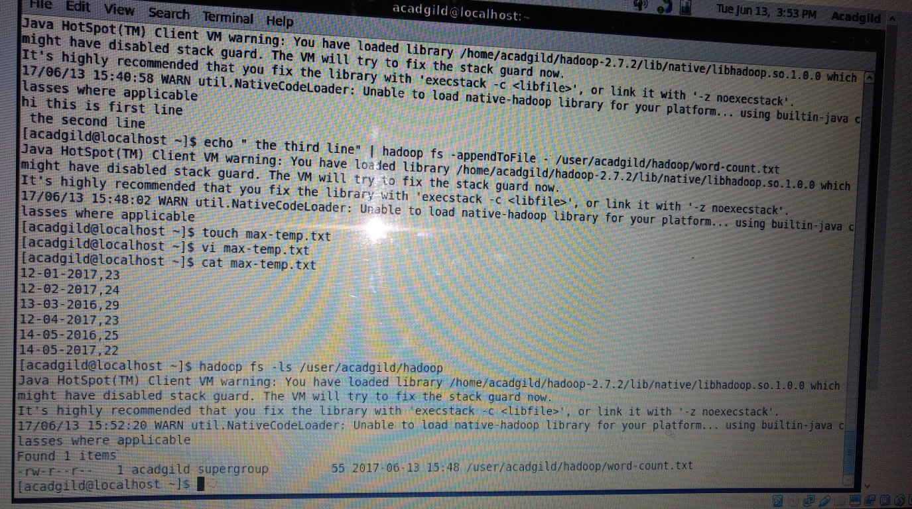

Move it to HDFS

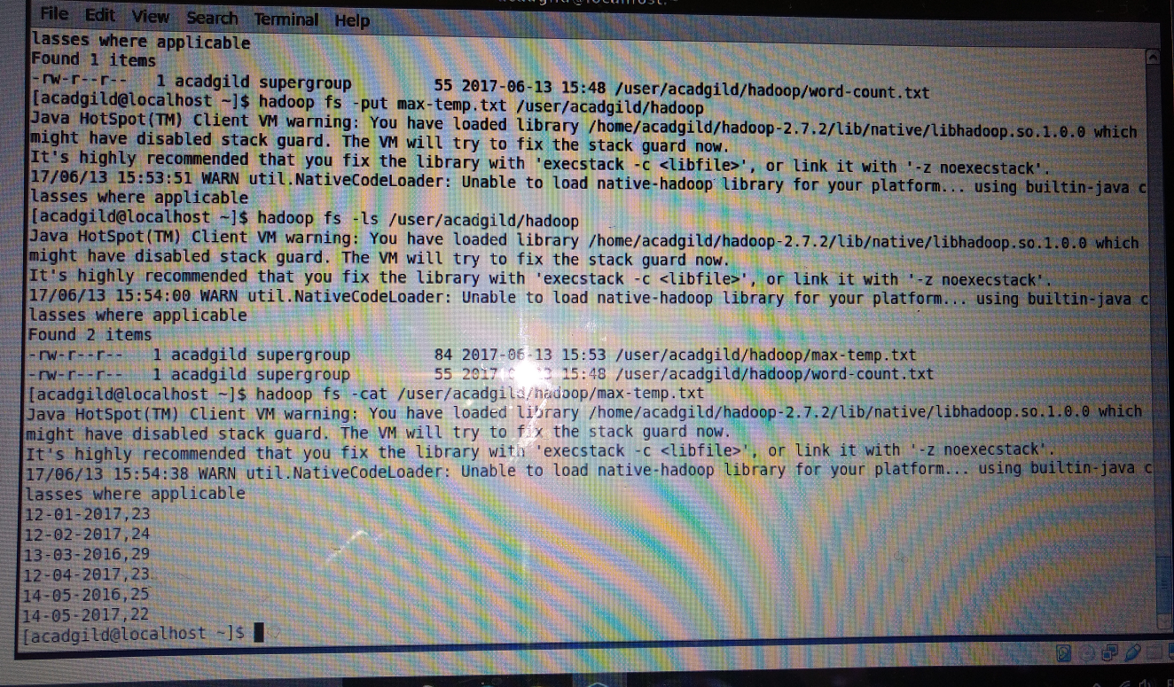

Task 2

Change permission

